ALEX NET

The Alexnet has eight layers with learnable parameters.The model has 3 fully connected layers with a combination of max pooling and in each of these layers use Relu activation except the output layer.

It was found out that using relu as an activation function accelerated the training process by 6times.Dropout layers was also used to prevent their model from overfitting.

The first convolution layer with 96 filters of size 11X11 with stride 4. The activation function used in this layer is relu. The output feature map is 55X55X96.

output size of a convolution layer = ((Input-filter size)/ stride)+1

Alexnet used Rectified Linear Units (ReLU) instead of the tanh function, which was standard at the time. ReLU’s advantage is in training time; a CNN using ReLU was able to reach a 25% error on the CIFAR-10 dataset six times faster than a CNN using tanh.

Back in the days Gpu’s were around 3 gigabytes.And Alexnet allowed multi Gpu training by putting putting half of the model’s neurons on one GPU and the other half on another GPU.

With this a bigger model can be trained and it cuts down training time.

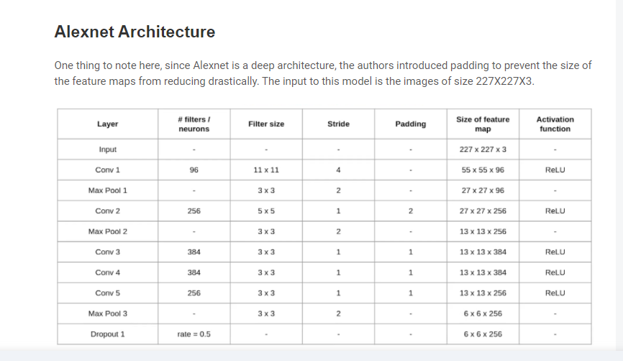

Advantages

* First major CNN model that used GPU’s for training. This lead to faster training of models.
* Deeper architecture with 8 layers which means that is better able to extract features when compared to CNN. It also worked well for the time with color images.
* The ReLu activation function used in this network has 2 advantages. It does not limit the output unlike other activation functions.
* It negates the negative output of summation of gradients and not the dataset itself. This means that it will further improve model training speed since not all perceptrons are active.

Disadvantages

* We can see that it takes more time to achieve higher accuracy results compared to future models.

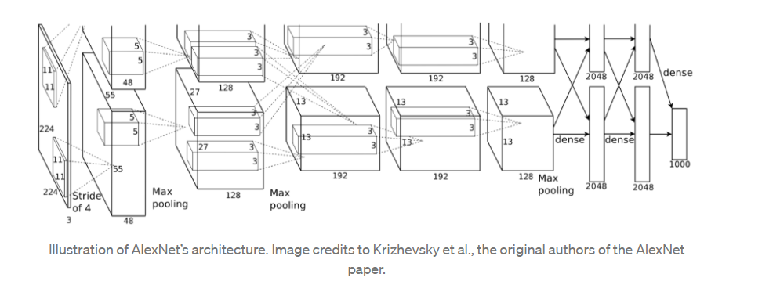

REFERENCES

[1] <https://www.analyticsvidhya.com/blog/2021/03/introduction-to-the-architecture-of-alexnet/>

[2] https://towardsdatascience.com/alexnet-the-architecture-that-challenged-cnns-e406d5297951